World Transplant Games
Invitation to Quote (ITQ)
Volunteer Uniforms

8th February 2019
v001
Section A – Introduction

- Requirements

  - Quotations are requested for the provision of Uniforms to support all volunteer requirements of the World Transplant Games 2019. The detailed requirements are defined in Section 2 - Specification.
  - Any queries relating to this document and/or Invitation to Quote quotation (ITQ) process should be sent to:
Sophie Hardwick
0191 4405754
sophie.hardwick@ngi.org.uk
  - Please note NGI will undertake due diligence checks on the selected provider prior to contract.

- Background
  - The World Transplant Games 2019 will take place in and around NewcastleGateshead from 17th – 24th August 2019. We are anticipating attendance from around 2500-3000 participants from over 60 different nations.
  - The World Transplant Games is the largest organ donor awareness event in the world. Held every two years, the Games are open for participation by athletes aged from 4 to 80+ years who have undergone lifesaving transplants. The Games comprises seven days of competition across around 16 sports and social gatherings for all delegates.
  - NewcastleGateshead Initiative (NGI) is the lead delivery partner, working closely with MLS Contracts Ltd, Transplant Sport UK and the World Transplant Games Federation who awarded the Games to NewcastleGateshead.
  - The UK hosting of the World Transplant Games 2019 provides a fantastic opportunity to raise awareness of donor registration and the benefits of a healthy lifestyle, alongside the opportunity to showcase the North East of England to a large contingent of national and international visitors.
  - For more information, visit: http://worldtransplantgames.org/

- Timetable

  - Please see set out below the timescale associated with this ITQ:
Stage | Date and time
Issue quotation request | Monday 11th February 2019
Deadline for any queries | Friday 1st March 2019 at 1pm
Quotation response deadline | Friday 8th March 2019 at 1pm
Evaluation of responses | Wednesday 13th March 2019
Contract award | Thursday 14th March 2019
Uniform delivery date | Thursday 1st August 2019

- Clarification Process

  - Any queries relating to this ITQ should be sent to:
Sophie Hardwick
sophie.hardwick@ngi.org.uk

Please note: If you wish NGI to treat a query (and answer) as confidential, you must state this when submitting your query. If, in the opinion of NGI, the query is not confidential, NGI will inform you and you will have an opportunity to withdraw it. If the query is not withdrawn, the response will be published on the relevant ITQ page on http://www.ngi.org.uk/ to enable all companies interested to have the same submission information. The name of the company raising the question will not be published.

The deadline for queries is Friday 1st March at 1pm.

- Responses

  - The completed ITQ should be sent via email to:
Sophie Hardwick
sophie.hardwick@ngi.org.uk

Please check the ITQ page up until the response date in case any answers to queries or additional information is posted.
Responses should be issued by Friday 8th March 2019 at 1pm.
  - Responses should include the following information:
Item
1 | Section C, Part 1, Organisation Details
2 | Section C, Part 2, Completed responses to Quality questions
3 | Section D, Completed Pricing Information
4 | Section E, Signature Form

- Evaluation of Quotations

  - Each response will be evaluated on a weighted combination of Price (70%) and Quality (30%). The quality questions are outlined in Section C.
  - The Price percentage will be scored as follows: (Lowest compliant bid price ÷ Potential Provider's price) × 70%
  - The quality score will then be added to the price score to give an overall score for that organisation.
Section B - Specification

- Specification

  - We require a supplier to provide the design, source, manufacture and deliver the uniform requirements for the World Transplant Games 2019.
  - The current uniform requirement is as follows:
    - Welcome ‘Team 19’ volunteers (approx. 400 uniforms required)
    - Sporting volunteers (200)
    - Physio/Sports Therapy volunteers (50)
    - Medical volunteers (25)
  - We anticipate that different types of volunteers would be distinguished by a different colour of teeshirt/jacket/fleece and with a single word on the back to distinguish the volunteer type – Team 19, Therapy, Medical, Sporting.
  - We anticipate that the requirements for each volunteer type will be as follows: (where is says ‘x 2’ it team 2 required per volunteer.

Volunteer type | Tee-shirt | Showerproof jacket | Outdoor fleece | Polo shirts | Caps | Drawstring backpacks
Welcome (400) | Yes x 2 | Yes x 1 |  |  |  | Yes x 1
Sporting (200) | Yes x 1 |  | Yes x 1
Therapy (50) | Yes x 2 | Yes x 1 | Yes x 1 |  | Yes x 1
Medical (25) | Yes x 2 | Yes (only 5 in total) | Yes x 1 | Yes x 1 |  | Yes (only 5 in total)

  - Your response should include providing at least 1 design for each uniform requirement.
  - It should also include 2 examples of that design working across your 4 proposed colour options for each volunteer type.
  - The quote should also include the specification for each uniform item proposed to provide information on its quality. Please also provide at least one alternative option if possible.
  - The uniform choice should take into consideration:
    - The time of year of the Games
    - The uniform will need to be adaptable across many different sizes, however we will gather size requirements where we can prior to production to reduce wastage.
    - Many volunteers may be working every day of the Games and may need to wash and dry uniform quickly.
    - The uniform will need to be robust and in keeping with the high quality of sportswear worn by competitors.
  - The logo that should feature on the front side of all Uniforms is as follows:
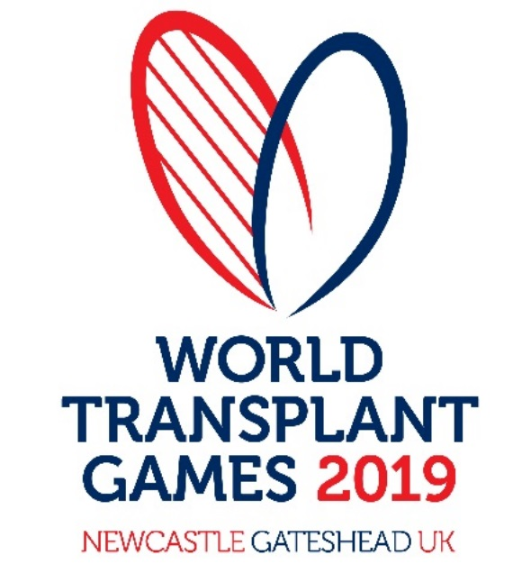
  - The Corporate guidelines for the use of the World Transplant Games logo and accompanying fonts is in Appendix 1.
  - An additional sponsorship logo might need to go onto the physio volunteer uniforms only.
  - All Uniform requirement should be designed in keeping with the look and feel of the Games and/or carry the main event logo.
  - Examples of uniform designs for previous World Transplant Games are in Appendix 2.
  - A sample of the intended uniform item and design for each uniform type will be required for sign-off.
  - Where possible we will look to achieving economies of scale between the volunteer uniforms and the merchandising requirement (such as the water bottles and tee-shirts), and therefore may require the suppliers of both activities to liaise on potential savings.
  - The Uniforms are required to be with NGI by the week ending Thursday 1st August, your submission should provide the key dates for design and sign off that would achieve this delivery date.
  - Any discounts, in-kind benefits or commitment to support the event would be valued by the Local Organising Committee. We will evaluate any discounted rate you propose in the evaluation process.

Section C – Supporting Information

Part 1 – Organisation Details

A-1 Name of your

organisation:

A-2 Registered office
(if applicable):

A-3 Trading address
(if different from
registered office):

A-4 Organisation
Registration Number
(if applicable):

A-5 Is your organisation a:
Sole Trader
Partnership
Public Limited Company
Private Ltd Company
Voluntary & Community Sector
Charity
SME (Small and Medium Enterprise)
Other

If you selected other,

please specify:

A-7 If the Company is a

member of a group of
companies, please give the
name and address of the
ultimate holding company

A-8 Name of person to whom

any queries relating to this
quote should be addressed

A-9 Telephone

A-10 Email

A-11 Address

(if different to the Address
above)

Please confirm that your company can deliver all requirements the timescales as detailed in the Specification (Section B) | Yes / No
Please confirm that your company implements due diligence procedures for its direct subcontractors to ensure that there is no slavery or human trafficking in its supply chains and that you will notify us, of any actual or suspected slavery or human trafficking in a supply chain which has a connection with this Agreement. | Yes / No

Part 2 – Quality Questions

As indicated in Section A, quality will amount for 70% of the evaluation to decide which quote to accept.

Question Number | Question Name | Question and Details
1 | Track record | Please provide samples (emailed photos and/or physical samples) of 2 previous uniforms that you have designed and delivered for similar events.
2 | Design | Please provide your first draft proposed design and specification for each of the uniform requirements listed. Please note we may not choose this design however this will give us an indication of the way your company would approach the design.
3 | Design – colour options | Please show two of the volunteer uniform requirements working across four colour ways for each volunteer type.
3 | Timeline | Please provide key dates for design, feedback and amends, sign off and delivery of the uniforms as per the specification.
4 | Manufacture | Please indicate where and which organisation will manufacture the uniforms and how you would guarantee delivery by the required date at the quality standards required (see T&Cs).
5 | References | Please provide 2 references for previous uniform projects you have delivered.
Section D – Pricing Information

As indicated in Section A, pricing will amount for 70% of the evaluation to decide which quote to accept.

Please insert your costs for each element of delivery in the table below. All costs must be in pounds sterling and exclusive of VAT.

Please note, we’re very keen to find a company that is willing to sponsor this activity. This is either in the form of a uniform supplier that can provide the uniforms at cost in exchange for logo recognition, or a sponsor that doesn’t provide uniforms who is willing to sponsor this as a stand alone activity. With this in mind, please include your market rate, and any potential reduced rate in your ITQ submission.

The submitted price should remain valid for a minimum period of 90 days.

Organisation Name
Quotation prior to any discounts (excluding VAT)

Please provide a quote for the uniform requirements specified in Section B – Specification.

Please also include and list if relevant any additional costs such as design, samples, travel, delivery and any expenses.

Total quotation (excl VAT) prior to any discounts offered:

Approaches from companies so far has indicated that some companies may wish to provide a discounted quote to support the World Transplant Games and / or in return for a solus branding opportunity on the uniforms or recognition as a sponsor at a level to the discount offer.

If this is of interest, please show your quotation at your discounted rate below.

Total quotation after any discounts offered (please write ‘not applicable’ if your company is not able to offer a discounted rate):

Please indicate your preference in terms of recognition if your company is providing a discounted rate:

Section E – Signature Form

Request for Quotation for: Volunteer Uniforms for the World Transplant Games 2019

I the undersigned hereby declare by marking an X in the box:

- that the information provided is complete and accurate;

- that the price is our best offer;

- that no collusion with other organisations has taken place in order to fix the price;

- to be subjected to the terms and conditions in Appendix 3;

- that no works/goods/supplies/services will be delivered or undertaken until both parties have executed a form of order and an instruction to proceed has been given by NGI in writing.

Name ...........................................................

Position Held.....................................................

Dated ..........................................................

Appendices

Appendix 1 – WTG Brand Guidelines
Appendix 2 – Terms and Conditions

